#### Additional Information:

The AUP Permission Slip can be found at: <http://www.christina.k12.de.us/technology/pdf/AUP_en.pdf>

For more detail about the AUP, please reference your Student Code of Conduct Handbook

(p. 59-61).

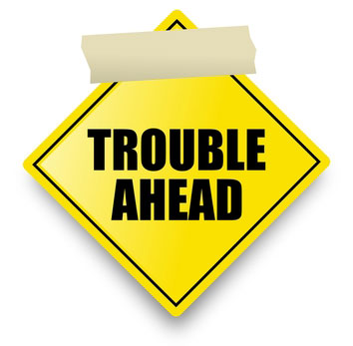

* Suspension or Expulsion in accordance with the Student Code of Conduct.
* Limitation or cancellation of user privileges.
* Legal actions taken by the school in collaboration with local, state, or federal officials.
* Full payment of any damages caused by willful user misconduct.

# Acceptable Use Policy (AUP)

Phone: (302) 631-2400

Keeping YOU and the SCHOOL safe!!!



#### Consequences for Inappropriate Usage:

190 Salem Church Road

Newark, DE 19713

Phone: (302) 631-2400

Website: [www.christianahs.org](http://www.christianahs.org)



**Christiana High School**

Christiana High School

# Do…

# Use technology for academic purposes.

* Access systems using only your authorized usernames/passwords
* Give credit to all sources used
* Use ONLY secure and protected sources
* Take responsibility for technology usage
* Report any inappropriate usage of technology
* Respect other users and their work



# What is an AUP?

* Do’s and Don’ts when using school technology (i.e. computers, networks, and the internet).
* Guidelines to protect both the school’s resources and yourself.
* Details consequences for inappropriate usage.

# Christiana High School AUP

**Technology is used in the Christina School District to support teaching and learning.** Users of the District’s computers and networks and the Internet (Web, e-mail, chat, messaging, etc.) **are responsible for their actions**. The use of technology in the District must be consistent with the academic goals of the school and the District. Access to the technology is given to students who agree to act in a considerate manner and **follow the Christina School District Code of Conduct, the State of Delaware Acceptable Use Policy and school rules when using the system.** Computer files and network storage areas will be treated like student lockers. System administrators and school staff may monitor or review files and communications to maintain systems integrity and to ensure responsible system use. **Violations may result in the loss of access as well as other disciplinary or legal action.**

# Don’t…

* Harass, insult, or attack others
* Intentionally damage computers, software, systems, or networks.
* Reveal personal information
* Send or display offensive messages or pictures
* Use obscene or profane language
* Violate copyright laws
* Use the network for illegal or commercial purposes
* Use another’s username and password
* Trespass in another’s folder, work, or files.
* 